Our Vision
At Summerville Primary School we recognise the beauty and wonder of maths and the significant contribution maths makes to everyday life. Mathematics is a universal language that enables us to understand the world. Beyond the study of numbers, shapes and patterns, it also provides important tools for work in fields such as engineering, physics, architecture, medicine and business. It nurtures the development of a logical and methodical mindset, as well helping to develop focus and the ability to solve problems.
Maths is a creative and highly interconnected and has developed over time. It is essential to science, technology and engineering and necessary for financial literacy and most forms of employment.
At Summerville Primary School, we:
- Foster a positive attitude to maths and believe that, ‘everyone can do maths’.
- Teach and practice the fundamentals of maths to develop greater recall and fluency
- Solve problems using different approaches and explain our reasoning.
- Use a concrete, pictorial, abstract, (CPA) approach to maximise conceptual understanding and expose mathematical structures
- Apply our skills and knowledge in other areas of the curriculum.
Our aim is to develop deep maths mastery; where pupils can apply their skills efficiently in a variety of contexts and explain why they chose a particular approach.
Curriculum Overview
Our scheme of work from reception to Y6, is based on the White Rose maths framework. We follow the order of blocks for each year group and the smaller teaching steps within each block. The aim is to develop pupil’s understanding of the big maths ideas as well as fluency and recall of numbers. We use equipment and visuals to aid understanding of concepts, before moving on to abstract recordings.
The expectation is that the majority of pupils will move through the scheme of work at broadly the same pace. However, decisions about when to progress will be based on the security of pupils’ understanding and their readiness to progress. Pupils who grasp concepts rapidly will56 be challenged through rich and sophisticated problems before any acceleration through new content. Those who are not sufficiently fluent with earlier material will consolidate their understanding, including through additional practice, before moving on.
Our focus on the automaticity of number facts allows pupils to approach new tasks confidently. A good knowledge of addition and subtraction facts to 20 (KS1) and of times tables facts up to 12 x 12 (by the end of Y4) leads to efficient calculating and frees up working memory for new learning.

EYFS
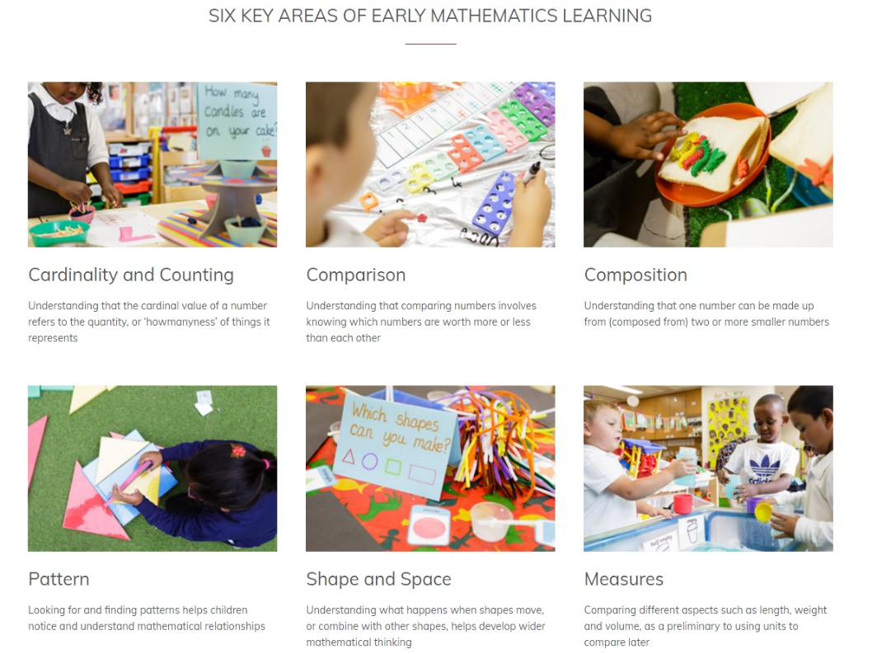
Nursery

Reception
Our reception maths curriculum embeds mathematical thinking and talk. Our scheme allows for key mathematical concepts to be revisited and developed further across the year. Our work builds on the five counting principles and develops pupils number sense.
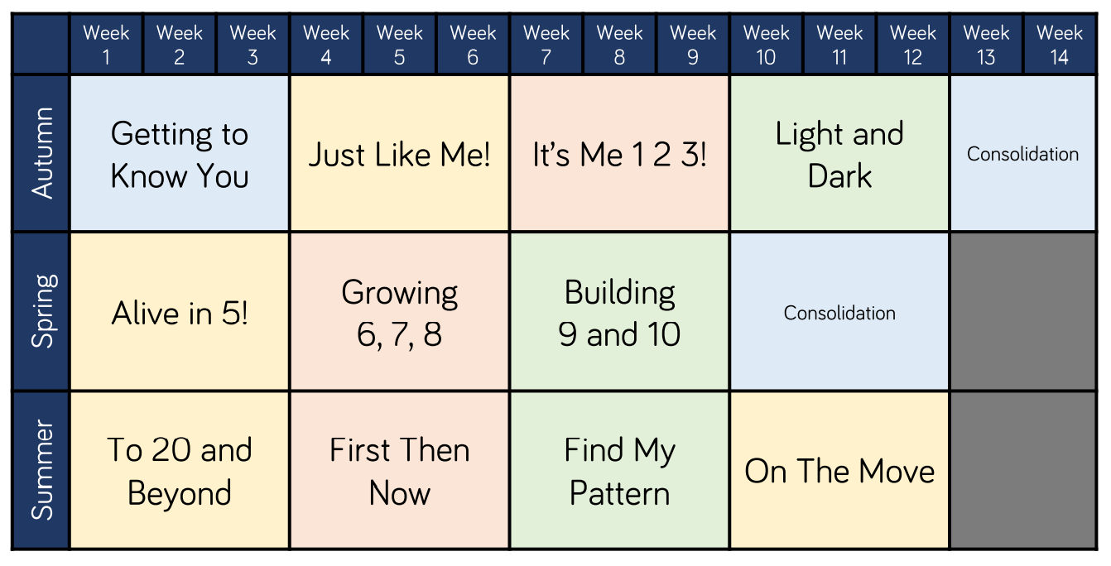
KS1 (Y1 and Y2)
The focus of mathematics teaching in key stage 1 is to ensure that pupils develop confidence and mental fluency with whole numbers, counting and place value. This involves working with numerals, words and the four operations, with practical resources [for example, counters and measuring tools]. At this stage, pupils will develop their ability to recognise, describe, draw, compare and sort different shapes and use the related vocabulary. Teaching will involve using a range of measures to describe and compare different quantities such as length, mass, capacity/volume, time and money. By the end of year 2, pupils should know the number bonds to 20 and be precise in using and understanding place value. An emphasis on practice will aid fluency. Pupils will read and spell mathematical vocabulary.

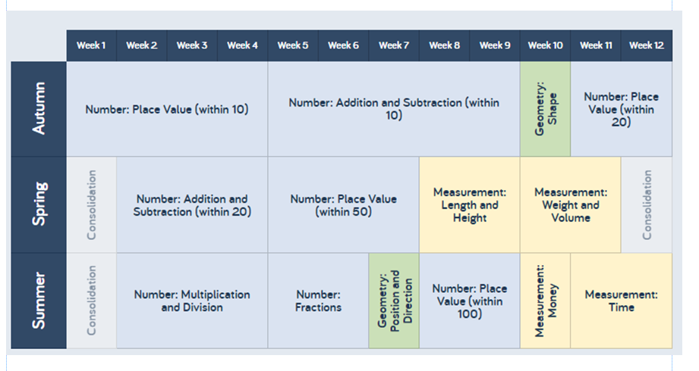

Year 1

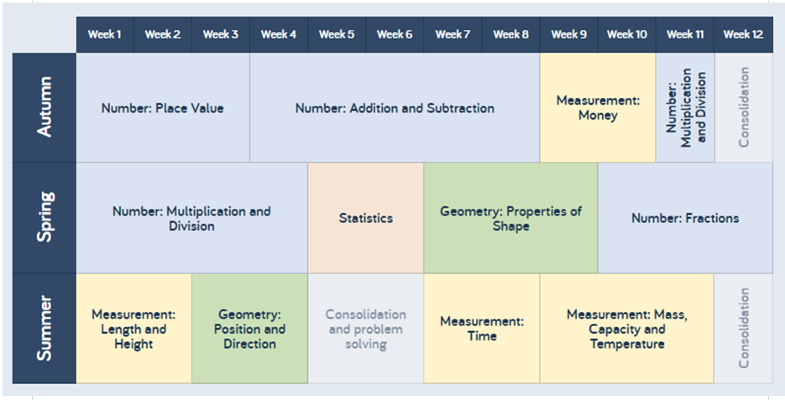
Year 2

LKS2 (Year 3and Year 4)
In lower key stage 2 the focus is on ensuring that pupils become increasingly fluent with whole numbers and the four operations, including number facts and the concept of place value. This will ensure that pupils develop efficient written and mental methods and perform calculations accurately with increasingly large whole numbers. Pupils will develop their ability to solve a range of problems, including with simple fractions and decimal place value. Teaching should also ensure that pupils draw with increasing accuracy and develop mathematical reasoning so they can analyse shapes and their properties, and confidently describe the relationships between them. Pupils will use measuring instruments with accuracy and make connections between measure and number. By the end of year 4, pupils should have memorised their multiplication tables up to and including the 12 x 12 multiplication table and show precision and fluency in their work. Pupils should read and spell mathematical vocabulary correctly and confidently.
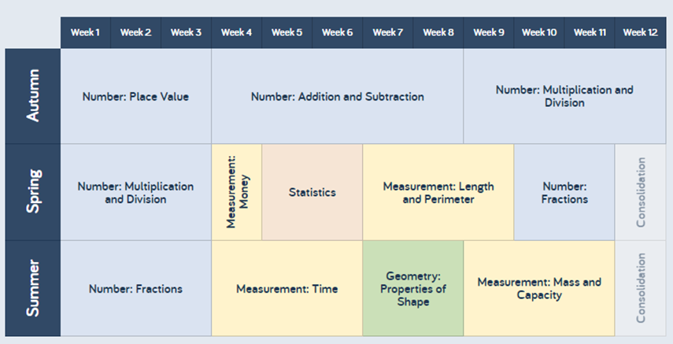
Year 3

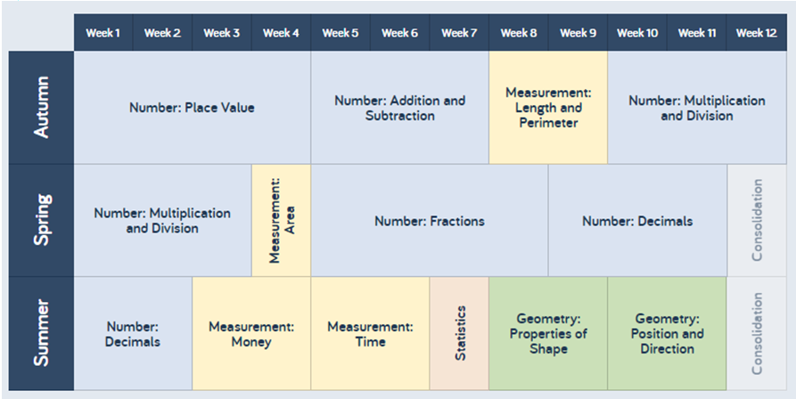
Year 4

UKS2 (Year 5 and Year 6)
The principal focus of mathematics teaching in upper key stage 2 is to ensure that pupils extend their understanding of the number system and place value to include larger numbers. This should develop the connections that pupils make between multiplication and division with fractions, decimals, percentages and ratio. At this stage, pupils develop their ability to solve a wider range of problems, including increasingly complex properties of numbers and arithmetic, and problems demanding efficient written and mental methods of calculation. With this foundation in arithmetic, pupils are introduced to the language of algebra as a means for solving a variety of problems. Teaching in geometry and measures should consolidate and extend knowledge developed in number. Teaching should also ensure that pupils classify shapes with increasingly complex geometric properties and that they learn the vocabulary they need to describe them. By the end of year 6, pupils should be fluent in written methods for all four operations, including long multiplication and division, and in working with fractions, decimals and percentages. Pupils should read, spell and pronounce mathematical vocabulary correctly.

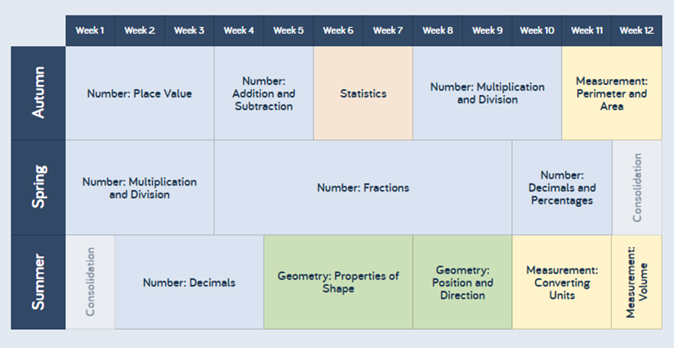
Year 5

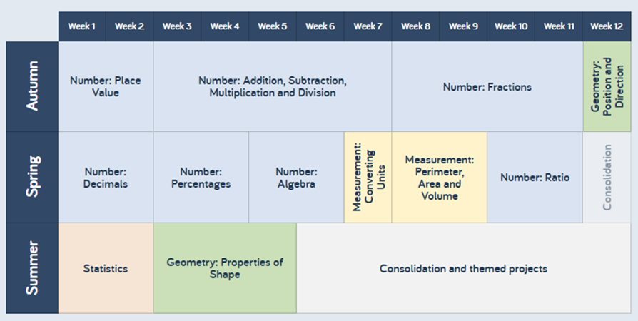
Year 6

